Satellite earth observation for assessing water quality, eutrophication and cyanobacteria in South African water bodies

mark william matthews

CyanoLakes (Pty) Ltd, 22 Midwood Avenue, Bergvliet, 7945, Cape Town, South Africa, Tel:+27217120764, Email:mark@cyanolakes.com

Outbreaks of cyanobacteria (blue-green algae) blooms and increasing eutrophication come at a considerable cost to industry, agriculture, humans and the environment. As a result, many of South Africa’s water supplies are under threat from deteriorating surface water quality. Tools from space-based earth observation allow systematic and near real-time operational monitoring and thereby provide quantitative measures for effective mitigation and management intervention. This study demonstrates the use of remote sensing from European Space Agency data to assess long-term changes in South Africa’s water quality, and for use in industry. The study shows cutting edge algorithm performance and operational analysis at sub-continental scales for southern Africa. The high temporal and spatial resolution provided by satellite observations provides unparalleled insights into the ecology and function of water bodies, and new insights into the phenology of cyanobacteria blooms and biological production in water resources. The use of the technology for industrial and environmental applications through products such as chlorophyll-a, turbidity and water colour (organic matter) is demonstrated.

Keywords: remote sensing, water quality, eutrophication, cyanobacteria

Introduction

The water crisis currently being faced by South Africa should need no introduction. The onset of the worst drought in three decades (1) leading to a shortage on already-strained water supply, coupled with deteriorating water quality through industrial and urban effluent provides a headache for authorities and a nuisance for the public. With less rain water to dilute effluent and waste water, the effect of water pollution is exacerbated. Recent studies show that as much as 70% of our potable water supply is eutrophic or worse (2,3), meaning it is enriched with organic nutrients (nitrates and phosphates) to the point of deteriorating the quality for recreation, ecosystem services and potable use. To make matters worse, blooms of toxin producting cyanobacteria, commonly known as blue-green algae, posing a high health risk to humans and animals have been identified in more than 50% of south Africa’s largest 50 water bodies (3). These toxins have a potency equal to snake venom, and result in the death of animals and humans, if ingested in high quantities.

These insights on the dire state of South Africa’s water quality originate from two independent data sources: firstly, from in situ data collected routinely by the Department of Water and Sanitation using conventional monitoring methods; and secondly, from data collected by satellite and processed using innovative and novel algorithms. Both data sources corroborate that eutrophication and cyanobacteria blooms are threat to the future supply of water in South Africa. The present paper aims to highlight the use and power of satellite remote sensing for systematic, long term water quality monitoring, and its use by government, industry and the public as a reliable and open information source. By highlighting ongoing projects and initiatives, it demonstrates how satellite technology can be used to compliment in situ monitoring, and provide unparalleled information on the ecology and changes in surface water bodies.

THE FUTURE OF WATER QUALITY MONITORING

Making use of the European Space Agency’s earth monitoring sensor the Medium Resolution Imaging Spectrometer, or MERIS, a ten-year record of South Africa’s water quality is available. MERIS, unlike other satellite instruments in space, was finely calibrated to detect water targets, which are significantly challenging from an engineering perspective due to the low signal from water. Combined with high instrument sensitivity, and rigorous sensor calibration, MERIS collected imagery every 2 to 3 days, with a ground resolution of 300 meters which provides more than 1000 scenes over South Africa between 2002 and 2012. Thus from MERIS we have a valuable record of environmental change over South Africa for a decade during the 2000s.

Following on from MERIS, ESA has launched the Sentinel series of satellites, and the Ocean and Land Colour Instrument, aimed at continuing the mission of MERIS to collect research quality data for monitoring earth’s environment (4). With the first satellite launched in January 2016, and two more to follow shortly afterwards, this will provide daily global coverage from 2019 onwards, providing an unparalleled ability to observe water quality in near real time from space, and data continuity till at least 2030. This will enable many near real time monitoring applications for water quality using satellite remote sensing. The advantages of utilising remote sensing alongside traditional in situ monitoring methods (whether automated or in the laboratory) are as follows:
- Enhanced spatial coverage without neglecting horizontal variability
- Reliable and systematic data coverage
- Low data cost
- Reduced latency (i.e. time between analysis and results)
- Potential to serve as early warning systems and forecasting services
- Availability of data records in remote or unmonitored regions
- Long, continuous time series not subject to human or conventional instrument failure

PUBLIC WATER QUALITY MONITORING SERVICES

Earth observation, by it’s nature, lends itself to services implemented for the benefit of society at large. The returns on the considerable investment should be firstly gained by the tax payers who ultimately have supported the advancement of space technology. “The integration of Earth Observation into the National Eutrophication Monitoring Programme”, or EONEMP for short, is a three-year project funded by the Water Research Commission to investigate the use of satellite earth observation for routine monitoring of 100 of South Africa’s largest water bodies. At the heart of the project is the delivery of an open public information service aimed at delivering up-to-date and reliable information on water quality to the public, and the government.

The project has already provided data on 100 water bodies by exploiting the MERIS record to the Department of Water and Sanitation for integration into the Water Management System database, the water quality information system used by the South African government. By analysing 10 years of MERIS data, the project seeks to answer questions such as “Which water bodies are most severely impacted by cyanobacteria blooms and eutrophication”, and “How frequently do cyanobacteria blooms occur”. This will assist the Department, and the general public and scientists, to pin point the problem areas and find solutions which address those water bodies most in need of remediation.
The study results will build on a published study, which investigated the 50 largest water bodies in South Africa (3). Finding from this study indicated that:
- Cyanobacteria blooms which pose a high health risk to animals and humans occurred in 26 of the 50 water bodies studied over the time period (Figure 1)
- On average, 78% (or 39) of these 50 water bodies were eutrophic or hypertrophic (severely nutrient enriched) (Figure 1)
- Satellite remote sensing estimates were highly correlated to independent data collected by the Department (Figure 2)
- Satellite remote sensing should be integrated into the government’s monitoring programs to compliment existing monitoring activities

Figure 1. Map of South Africa showing location of 50 water bodies and A) average concentration of chlorophyll-a, B) average area coverage of cyanobacteria blooms (3).
2012
2002

Figure 2. Comparison between 2002 and 2012 of satellite estimated chlorophyll-a and that measured by the Department (3).

In addition to providing historical information, EONEMP will launch a website dedicated to near real time monitoring utilising data from Sentinel-3. This will serve as a public warning and information service, from which both the general public, government and scientists can obtain valuable information open source (see www.cyanolakes.com/EONEMP/). This will enable South Africans to better understand and take ownership of the deterioration of water quality, and help find solutions and avoid needless health consequences.

COMMERCIAL WATER QUALITY MONITORING SERVICES

The needs of the commercial sector with regards to water quality can be addressed by satellite remote sensing methods. For example, in the case of water treatment works for producing potable water from raw water, the concentrations of algae or cyanobacteria, total suspended matter, and organic colour (dissolved humic and fulvic acids) have far reaching consequences for the design of structures such as settling ponds. Remote sensing can provide information on these and other parameters which affect the colour of the water, including includes total suspended solids, algae and cyanobacteria, and organic colour (Figure 3).
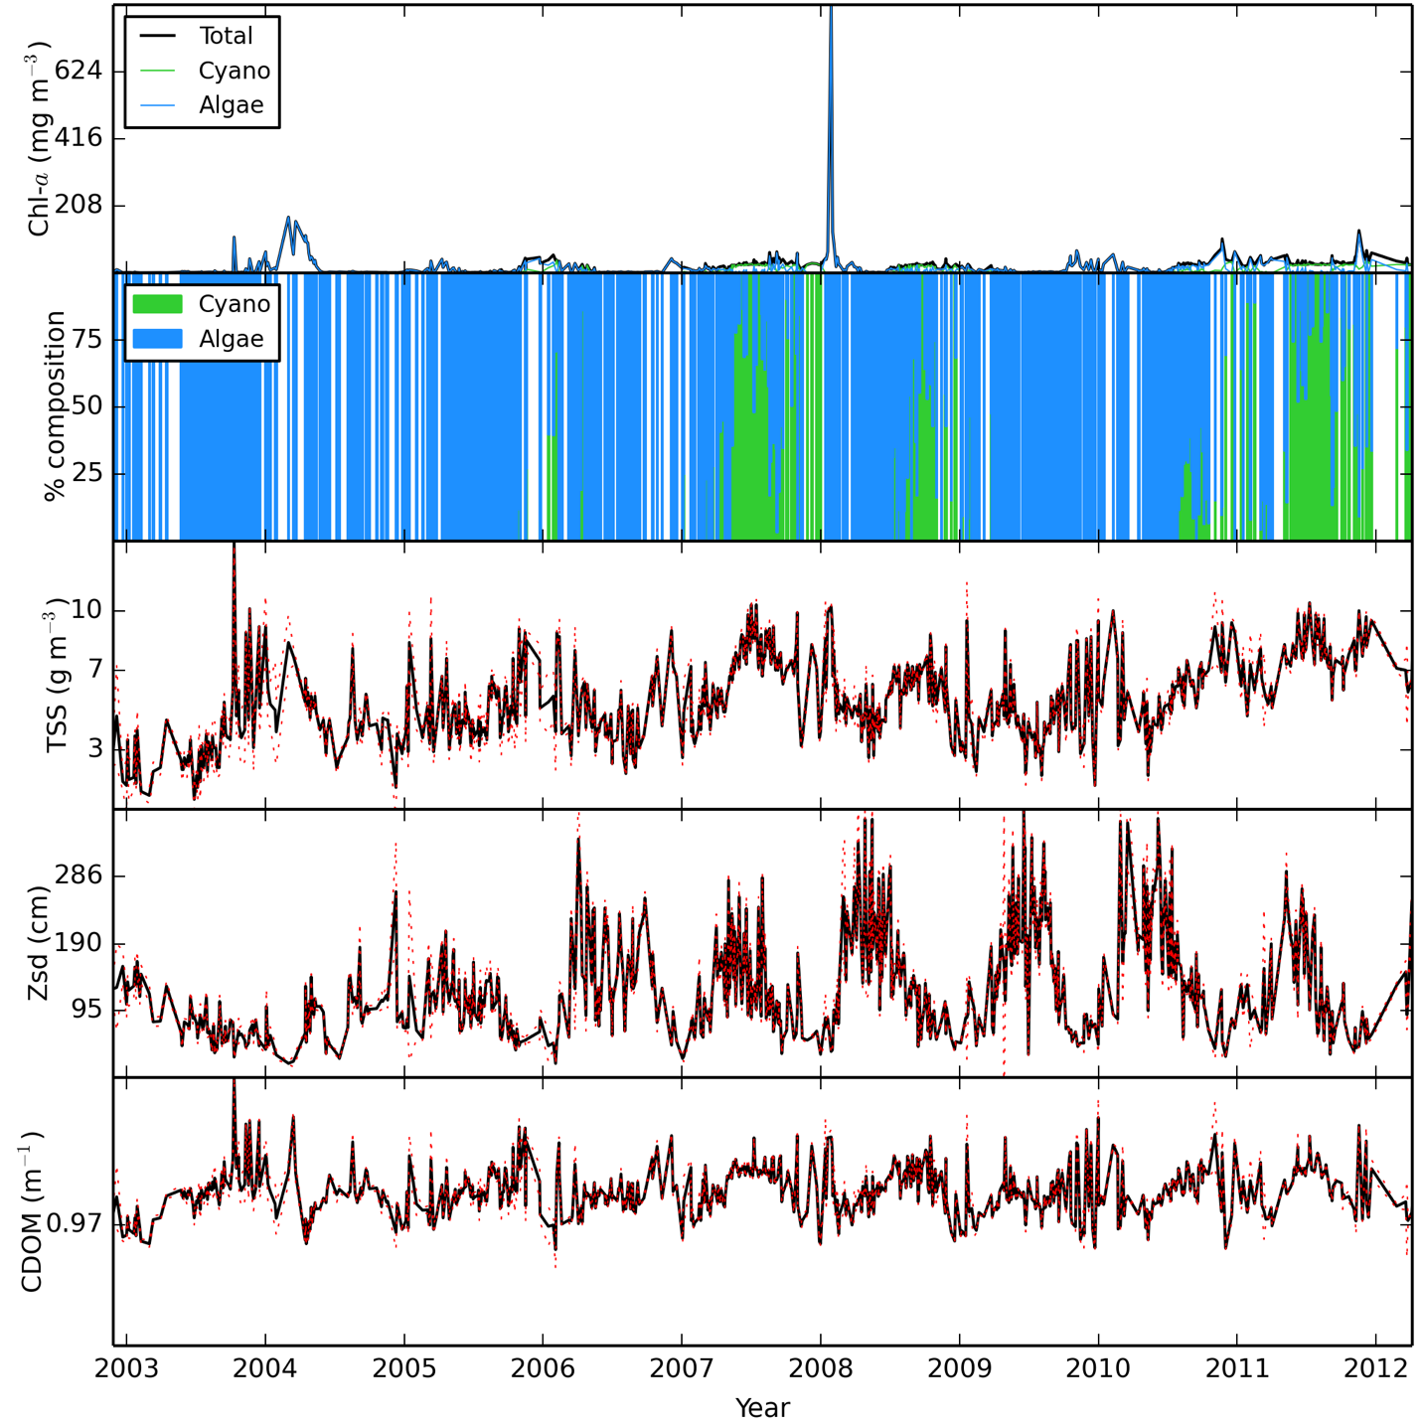
Figure 3. Time series from MERIS for, from top, chlorophyll-a, the percentage composition of cyanobacteria versus algae, concentration of total suspended matter, Secchi Disk depth, and absorption by coloured dissolved organic matter (CDOM) for a small South African reservoir.

Furthermore, this information can provide crucial information for background ecological and engineering studies for areas in which in situ sampling is lacking or even entirely absent. Instead of setting up costly in situ sampling programs with high cost and slow turn around times, satellite remote sensing can be used to characterize seasonal and annual changes in water quality without the need to establishing an in situ water quality monitoring programme (Figure 4). If necessary, validation can be performed on a limited basis to assess the accuracy and performance of satellite based algorithms.

Figure 4. Average seasonal variability of chlorophyll-a concentration, showing standard deviation error bars derived from MERIS time series.

Using advanced time series analysis methods, more difficult questions may be answered such as “how persistent are cyanobacteria blooms?” or “is there a correlation between water level and water quality?”. Autocorrelation analysis using anomalies calculated by subtracting weekly climatological averages from weekly data, provides an indication of the persistence of anomalously high chlorophyll-a events (algal blooms), which may impact on water treatment infrastructure, and affect design (Figure 5). The autocorrelation measures the correlation coefficient of the time series against itself for various time lags. The significance level is 95% below which the correlation is deemed insignificant, enabling the determination of the de-correlation time scale or the time-lag at which the time series is no longer correlated with itself.

Lead-lag correlation analysis can provide insights into how water quality responds to water level changes in a reservoir. This effectively shows seasonally driven changes in water quality associated with rainfall and climate, or alternatively with anomalously low or high events. Correlation was computed with data binned to monthly averages, and time lagged by 15 months to indicate the response to monthly average water level data (Figure 6). It is evident that chlorophyll-a is significantly correlated with water level with a lead of 3 months, that is the highest chlorophyll-a concentrations precede the highest water levels by 3 months. The same analysis can be performed for suspended solids or any other parameter derived from satellite data. Providing answers to these questions can significantly enhance ecological and engineering studies which are dependent on information on persistence of anomalous (out of the usual average) events.
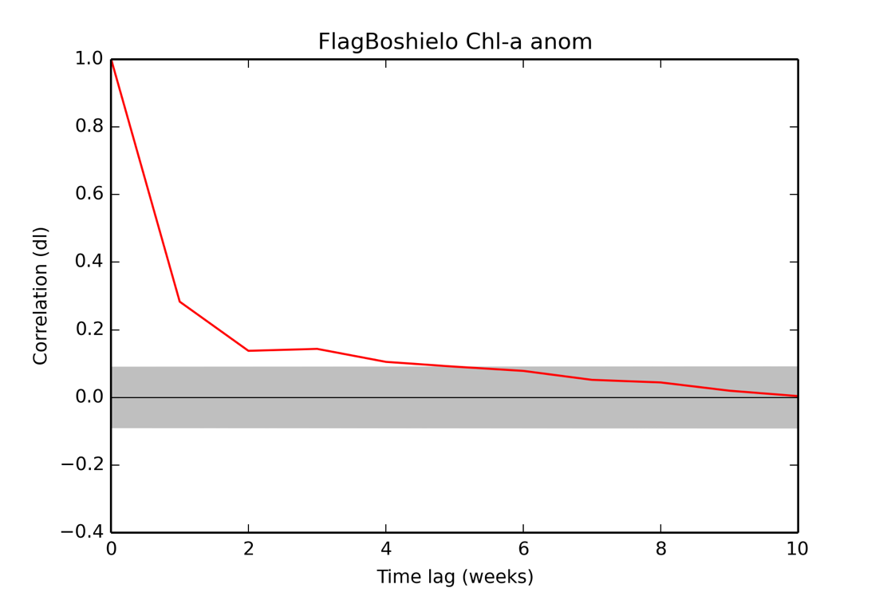
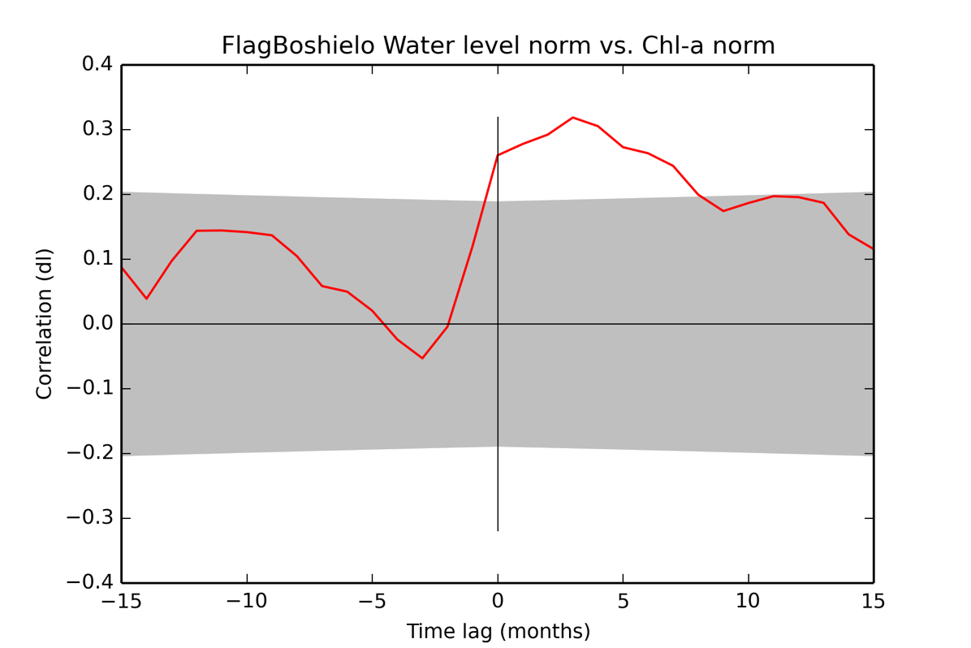
Figure 5. Autocorrelation for chlorophyll-a indicating the persistence of anomalously high events is up to 4 weeks at which stage the correlation is no longer significant (correlations below a 95% significance level are shaded).

Figure 6. The lead-lag correlation coefficient between water level and chlorophyll-a concentration (correlation coefficients below a 95% significance level are shaded).

CONCLUSION

This paper has demonstrated the use of satellite earth observation for both public and commercial applications related to water quality monitoring. Analysis of satellite based observations can significantly enhance traditional data collection methods and monitoring programs implemented in the benefit of the public, and enable new insights and kinds of analysis to be performed according to the needs of the commercial sector. The future of satellite water remote sensing looks bright thanks to significant investment in technologies in support of downstream applications with lifetimes lasting till at least 2030, and which are likely provide significant advances along the way.

REFERENCES

1. S Allison, “Farmers bear brunt of South Africa’s severe drought: ‘All we can do is pray’”, The Guardian, http://www.theguardian.com/global-development/2015/nov/17/farmers-bear-brunt-of-south-africas-severe-drought-all-we-can-do-is-pray (2015)
2. B Harding, Transactions of the Royal Society of South Africa, p.1-17 (2015)
3. MW Matthews, SAJS, 111 5/6 p.1-8 (2015)
4. European Space Agency, https://sentinel.esa.int (2015)

